Vertex buffer

Remove the word vertex, than it’s just buffer

A buffer is just a portion of memory

But here in open gl, it is actually in the graphics

It is actually a portion of memory present in the video RAM

Shadder

A shadder is a bunch of code that runs on the gpu

Let say we store data about triangles on the buffer ( video ram )

Now we need to tell the gpu, okey here is the data about the triangle now I want you to draw and rasterize me a triangle

We need to tell the gpu what to do

So, we need to program the gpu

And that’s what the shadder is

That bunch of code running on gpu is shadder

Let say we want to draw triangle

Actually open gl already knows what buffer, what shadder to use to draw something. So actually we tell open gl, select this buffer, select that buffer, select this shadder, select that shadder, and then draw me a triangle

Based on what buffer and which shadder we’ve selected that’s going to determine what is going to get drawn

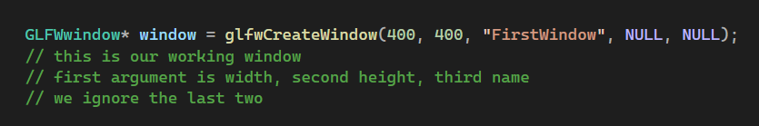

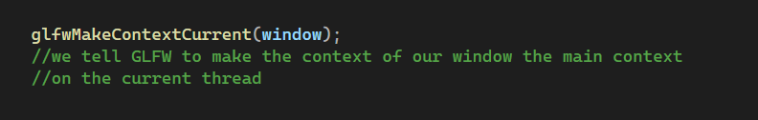

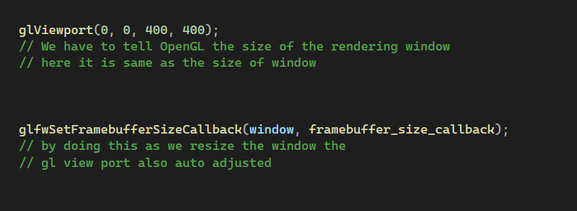

Where framebuffer_size_callback is a callback function which is defined as :

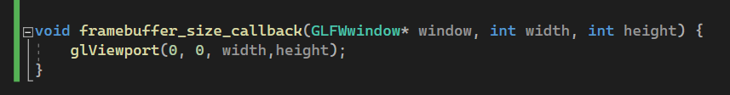

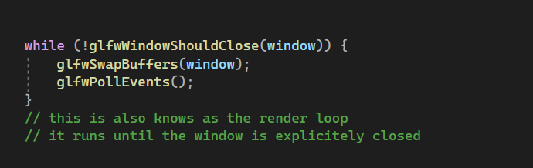

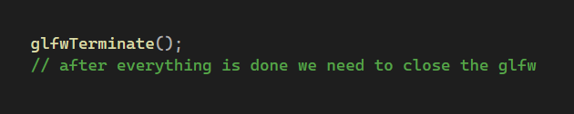

Handling input inside the render loop

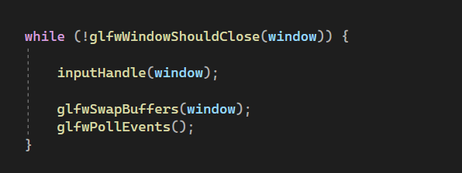

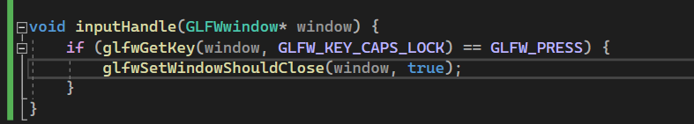

So here if user press caps lock the window closes

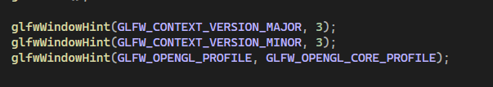

GLFW do not the version of the opengl we are using

So, by this we tell the GLFW the version of the open gl we are using

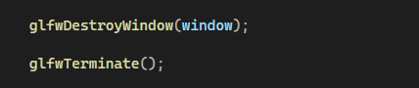

Here glfDestroyWindow(window) is just the destructor that is destroying the created window object